**ASSIGNMENT ON GIT:**

**PRN : 210943120020**

**NAME: Tushar Badgujar**

1. Create a local git repository with angular/JAVA  
   project

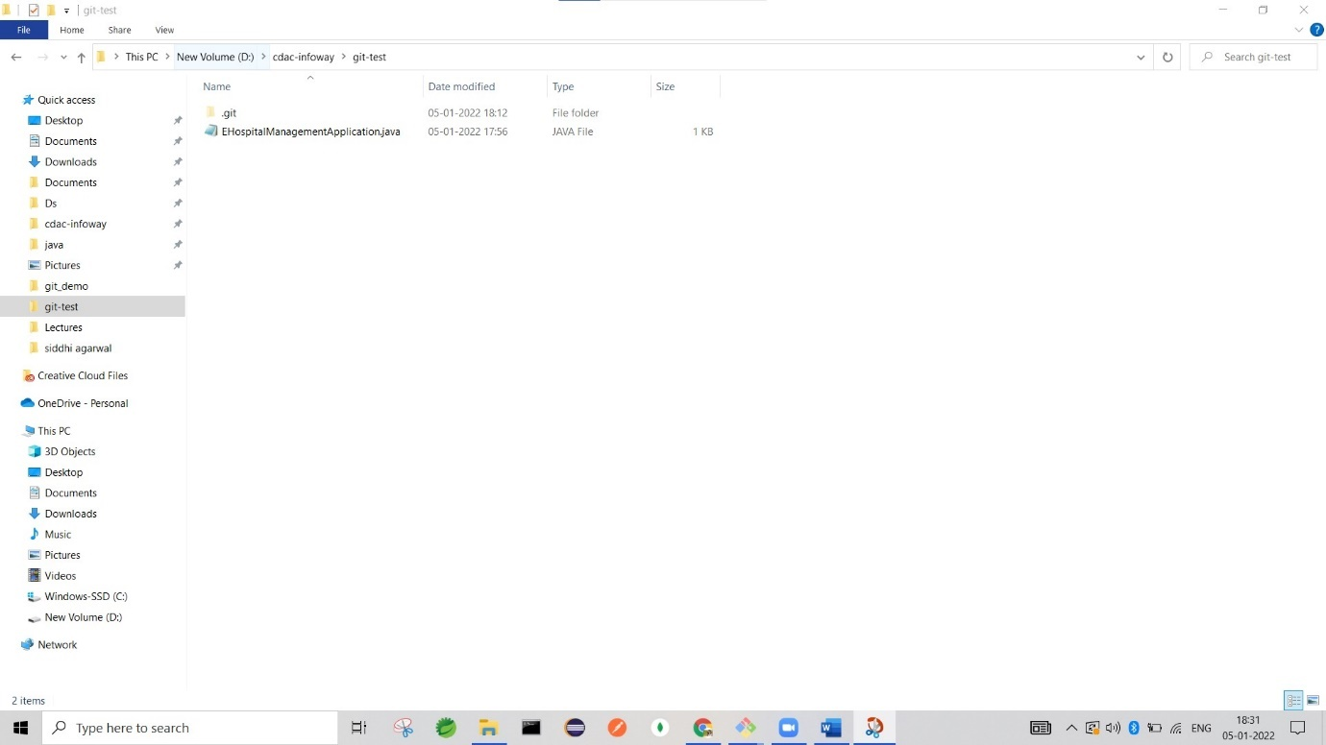  
  
  
2.       
Commit the initial code  
  
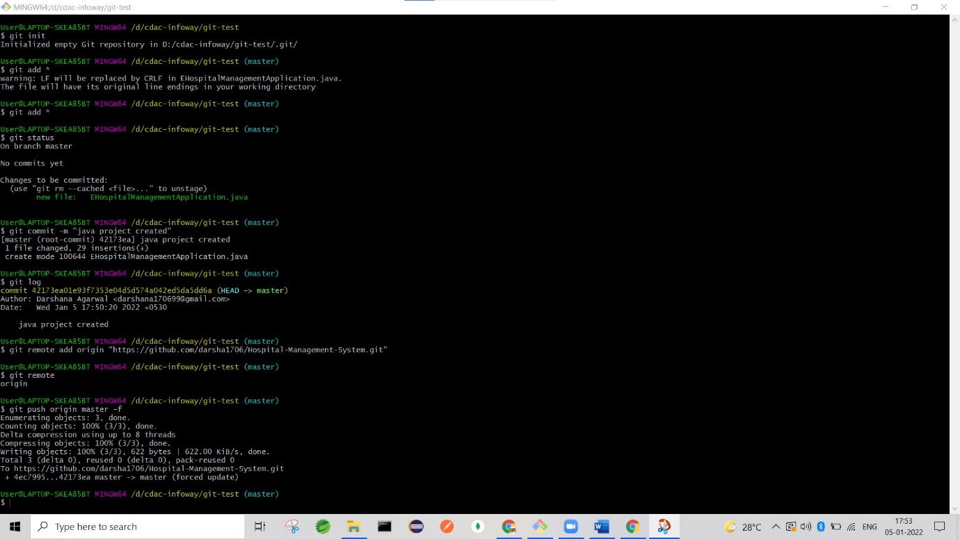

1. Update the code  
   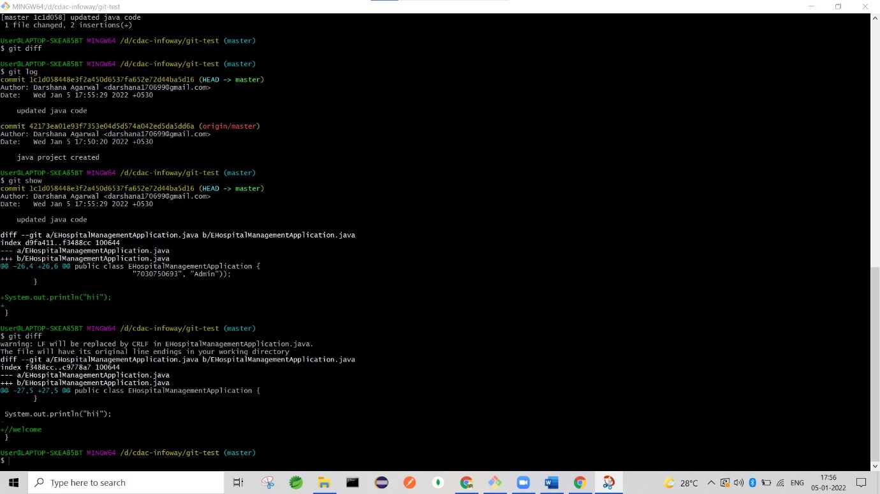

4.       
Use git commands to  
  
o Get the updated files  
  
o List the changes  
  
o Create a branch  
  
o Merge brancH

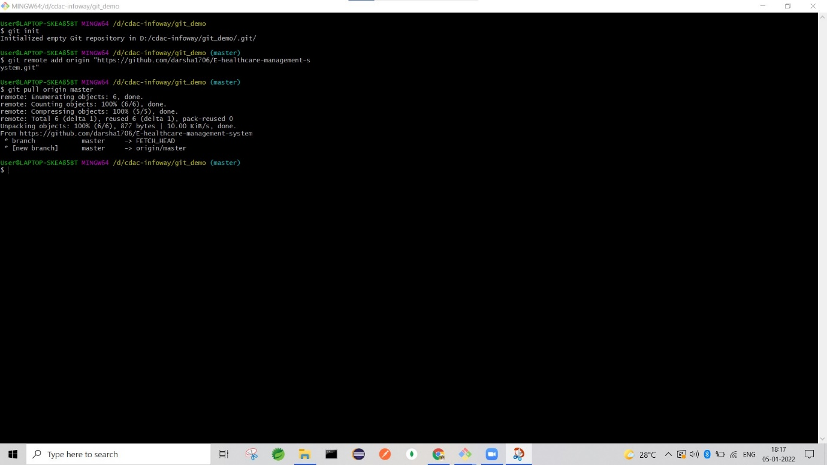  
  
5.       
Create a repository on GitHub with the angular project name

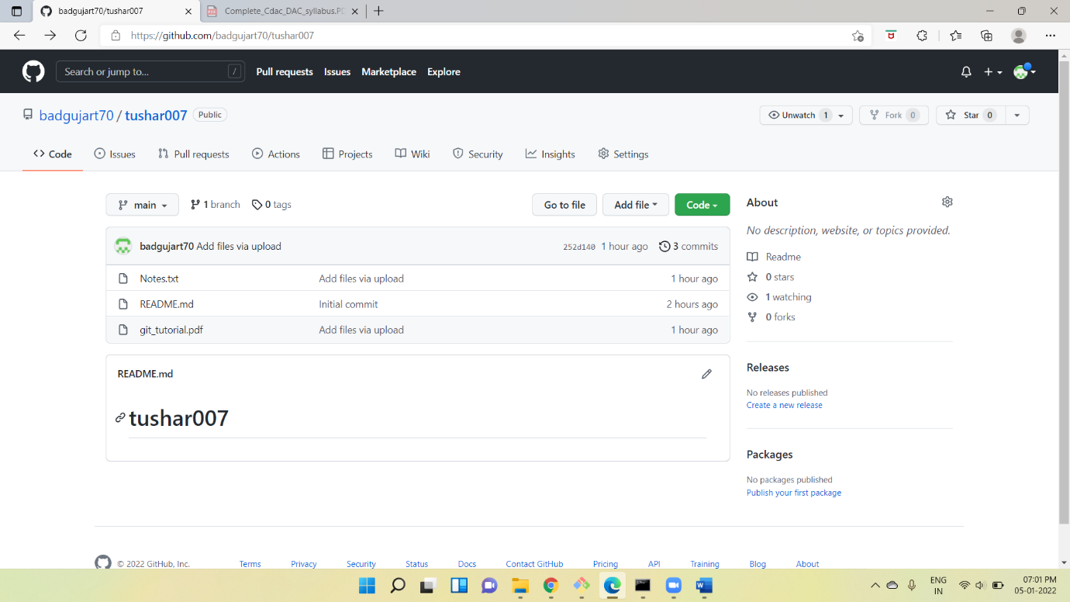

6.       
Push the local changes to GitHub  
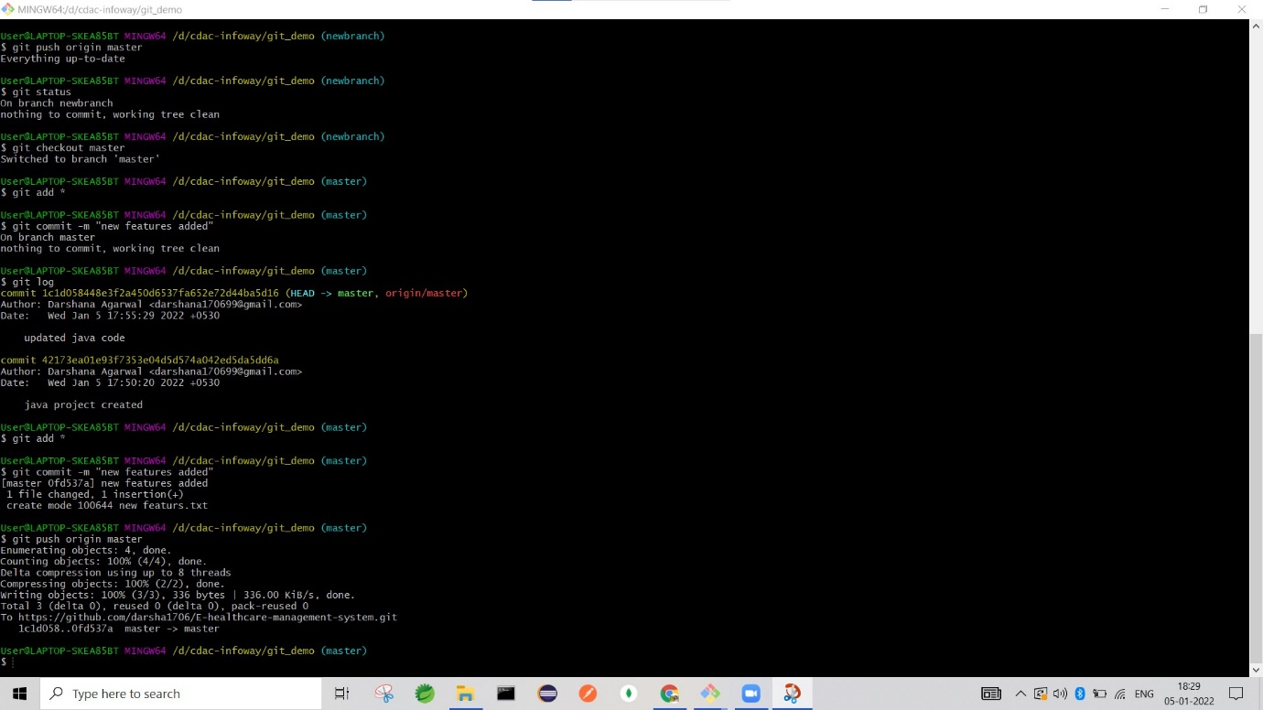  
  
7.       
Pull the code from GitHub  
  


8.       
Create and check out a branch  
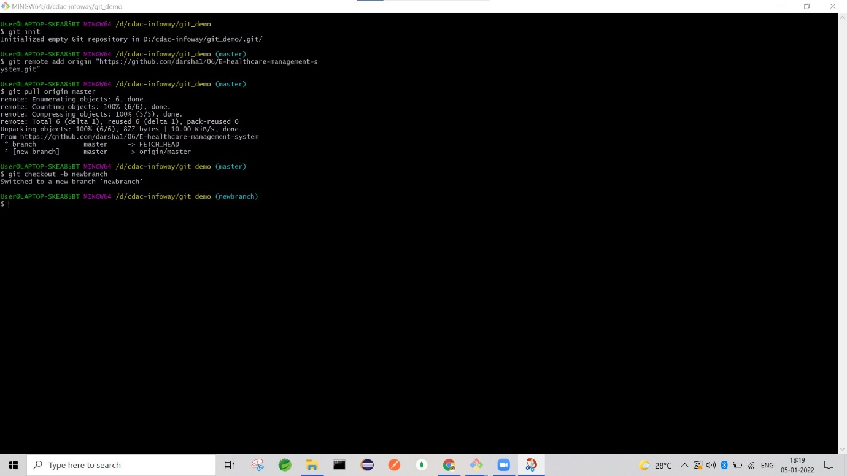  
  
9.       
Add a new feature, commit and push changes to  
GitHub  
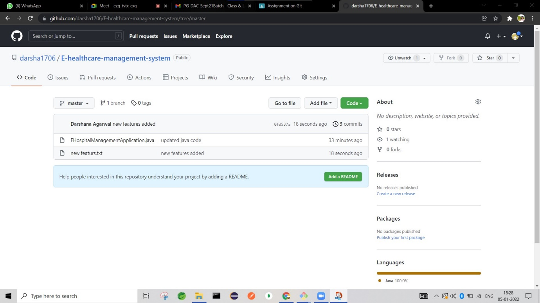

10.    
Create a pull request  
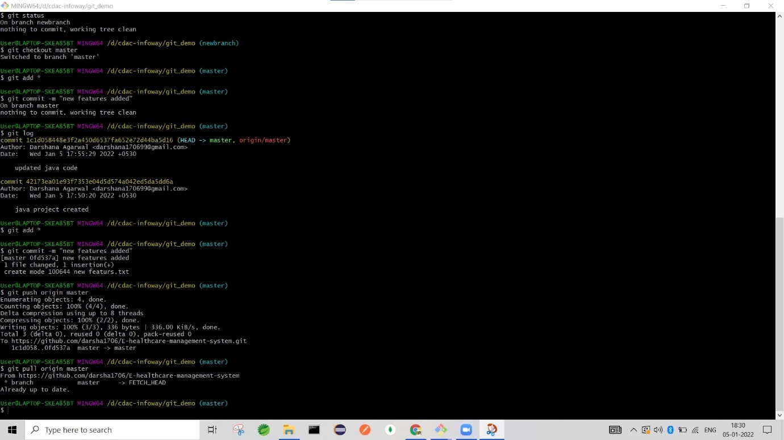

11.    
Review the changes on GitHub and merge the  
branch into the main branch

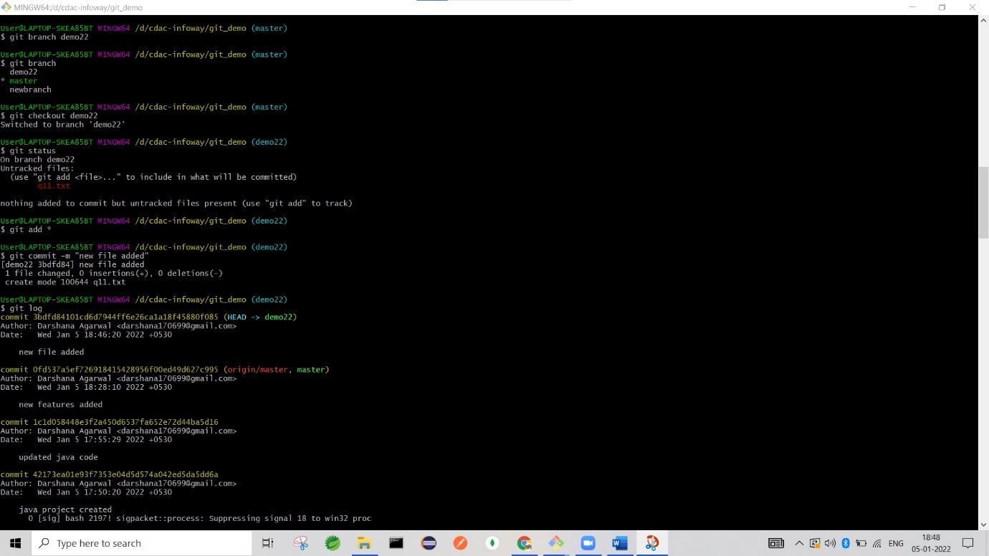

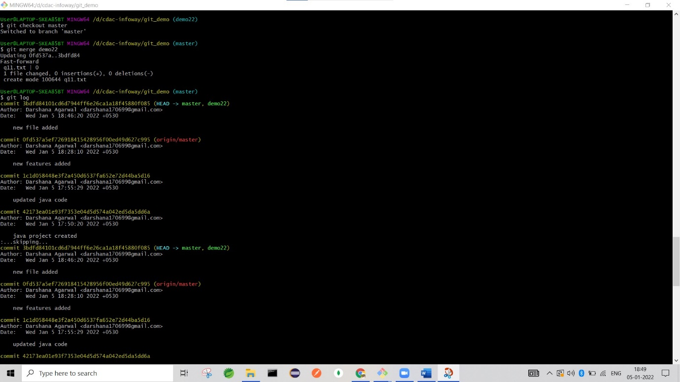

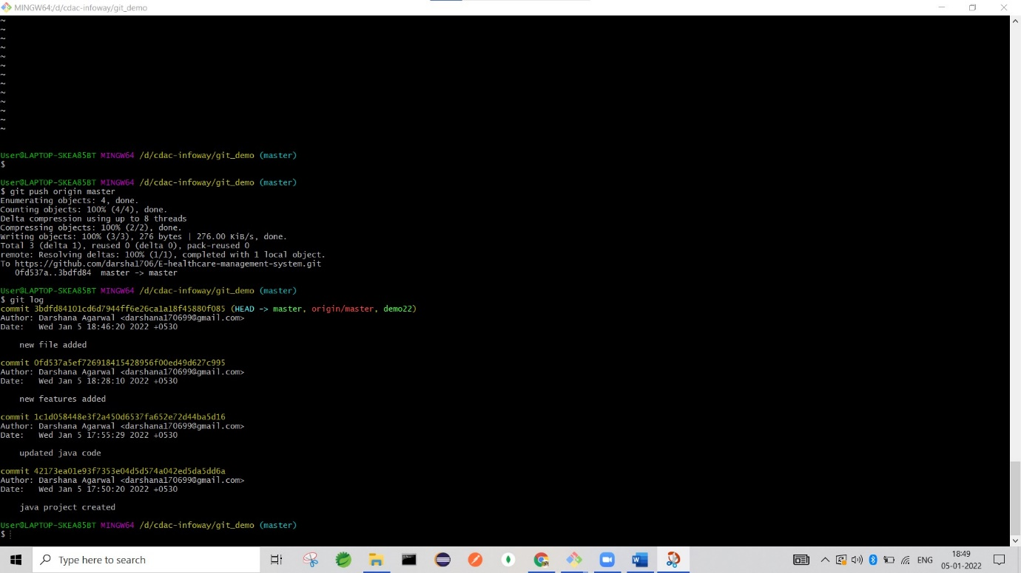

History:

240 git init

241 git add *

242 git status

243 git commit -m "welcome to system"

244 git log

245 git remote add origin "https://github.com/darsha1706/Hospital-Management-System.git"

246 git remote

247 git push origin master

248 git push origin master -f

249 git add *

250 git init

251 git add *

252 git add *

253 git status

254 git commit -m "java project created"

255 git log

256 git remote add origin "https://github.com/darsha1706/Hospital-Management-System.git"

257 git remote

258 git push origin master -f

259 dit add *

260 git add *

261 git add *

262 git diff

263 git commit -m "updated java code"

264 git diff

265 git log

266 git show

267 git diff

268 git branch

269 git branch test

270 git branch

271 git checkout test

272 git log

273 git checkout master

274 git log

275 git merge test

276 git remote add origin "https://github.com/darsha1706/Hospital-Management-System.git"

277 git remote add origin "https://github.com/darsha1706/E-healthcare-management-system.git"

278 git remote add origin1 "https://github.com/darsha1706/E-healthcare-management-system.git"

279 git remote

280 git push origin1 master -f

281 git pull origin1 master

282 git branch